Bài 2
https://www.figma.com/design/HgUaSvZoETZOozS0qHiU3X/Untitled?node-id=0-1&p=f&t=ZMHb63DDMx4uqkD7-0
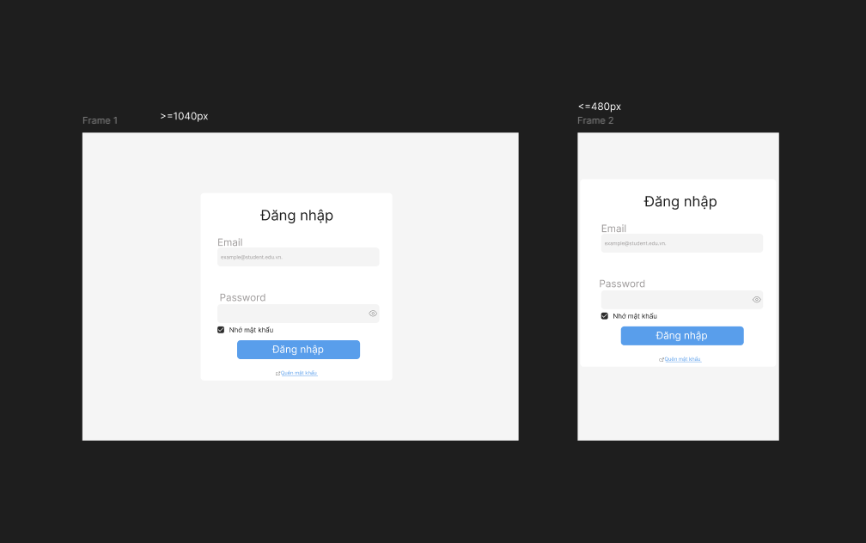

Bài 3

